Pokhara University

Level: Bachelor | Semester – Spring | Year : 2005
Programme: BE |  | Full Marks : 100
Course: Control System |  | Time : 3hrs.

Candidates are required to give their answers in their own words as far as practicable.
The figures in the margin indicate full marks.

Attempt all the questions.

1. | a) Obtain the transfer function X₂(s)/F(s) of the mechanical System:  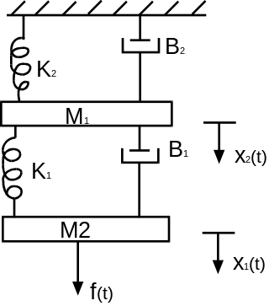  b) Determine the overall transfer function of the system represented by the following block diagram. (Assume all the feedbacks are negative and parallel path are positive).  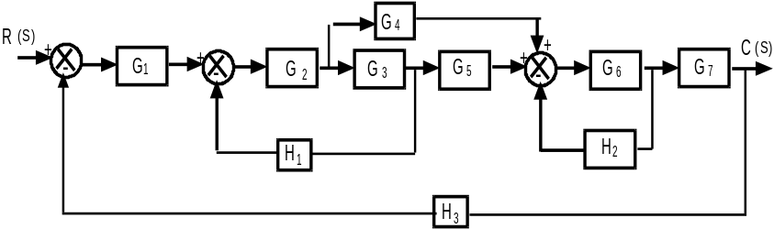 | 7  8
2. | a) Obtain the over all transfer function of the system shown in figure using signal flow graph technique.  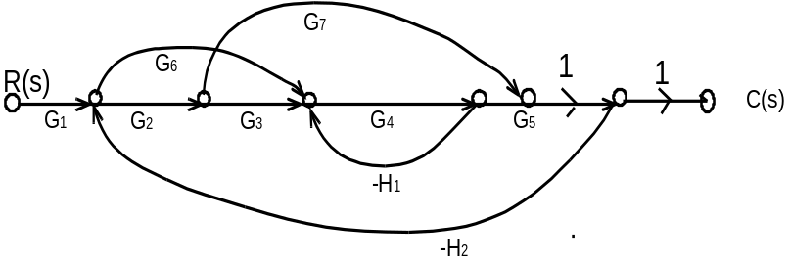  b) The closed-loop transfer function is given by  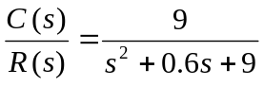  - Obtain the unit-step response of the system.  - If the input r (t) to the system is r(t) = 1 + t + t²/2, what is the steady state error in the system response. | 7  8
3. | a) Sketch the root locus of a open loop transfer function with unity feedback as 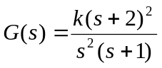  i) Determine the range of k for stable operation.  ii) Determine the imaginary axis cross-over point.  iii) Calculating the real axis break away point, sketch the form of the root in the system.  b) What do you mean by Polar Plot? How can you determine relative stability by using it. | 8  7
4. | a) Determine the resonant frequency, w_{r}, resonant peak Mp and band width for the system whose transfer function is 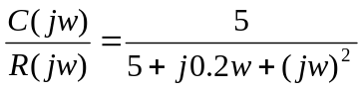  b) Draw Bode Plot of the system 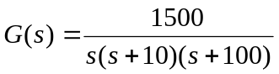 and also calculate the, phase and gain margin. | 6  9
5. | a) Determine the range of K for which the system having characteristic equation as follows is stable.  s(s² + s + 1) (s + 4) + K = 0  b) For the following circuit determine its state space representation model.  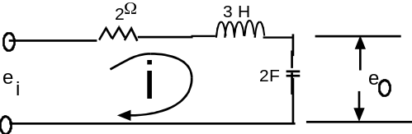 | 8  7
6. | A system represented by open loop transfer function with unit feedback 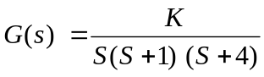; has the following requirements:  - daming ratio of the dominant pole = 0.5  - settling time = 10 sec.  - velocity error constant > 5 sec⁻¹  Design a lead compensator to achieve the required response. | 15
7. | Write short notes on (Any Two):  - Gain and Phase margin  - Transient and Steady state Response  - Steady-state error | 2x5

